Dual collection approach (text chunks + images)
Introduction
In a multimodal Retrieval-Augmented Generation (RAG), there are two sorts of inputs that are essentially different: text and graphics.
Text usually provides users with information on procedures, guidelines, cautions, or other clarifying remarks about the text. However, graphics such as flow charts, schematics, layouts, and labels for mechanism components can visually convey to users what has been spoken or explained.
Combining text and visuals into a single collection of vectors may cause problems with the following, even though both will typically be transformed and stored as embeddings:
- A decrease in the accuracy of document retrieval from the database.
- The incapacity to filter recovered documents according to their medium
- Accidental confusion while attempting to make the connection between a written description and a graphic explanation.
A dual collection methodology is utilized to address these problems, with vector collections for text and graphics maintaining a logical relationship through metadata.
Why is a dual collection Approach needed?
- Different Semantic Functions
  - Image embeddings correspond to geographical relationships and visual characteristics, while text embeddings convey linguistic meaning. Combining the two modalities may distort similarity searches.
- Retrieval specific to modality
  - Certain user queries will yield a graphic or other visual depiction, while others will simply yield a text explanation. The user might get just what you needed with distinct collections.
- Improved management of metadata
  - Text chunks and images have separate metadata. Dual collections allow each to maintain its own metadata that is relevant to the structure of each collection.
- Maintainability and Scalability
  - Instead of interacting with one another in any manner, the collections can be individually indexed updated or optimized.
How the dual collection design work?
The Text Collection contains certain metadata related to the document or documents being indexed, such as the document name, section title, and page number, and stores portions of document text as embeddings.
In addition to storing embeddings of images taken from the documents, the Image Collection contains metadata (image file name, source document, and related page number) that is also connected to the document or documents being indexed.
Because both collections have a similar identifier (either document_id or page_number), the system can link the related text and images and retrieve them together when necessary.
Data flow overview
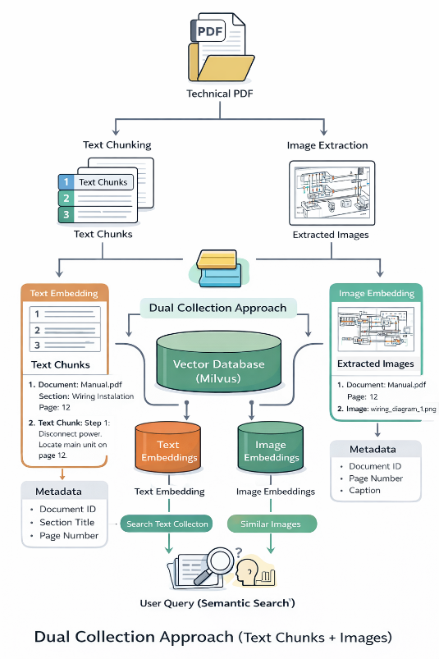
A dual collection method that stores textual and visual data in different but connected vector collections has been created to effectively manage and retrieve both types of data from technical files. The technique generates a single vector representation for every kind of extract and uses the same vector database for every collection, using text data from a text embedding model and image data from a multimodal model (like CLIP). Textual and visual extracts from the same source can be logically connected since each vector in both collections is enhanced with shared metadata.
Using the same query input, the system conducts concurrent similarity searches across the text and image libraries, enabling it to obtain both pertinent text and supporting visual content. By keeping the text and image collections apart, we can increase each one's retrieval accuracy, simplify the search system, and improve the retrieval-augmented generation pipeline's capacity to produce more precise and comprehensive results by offering both contextualised visual data and language-based explanations.
Screenshots
